Hamiltonian-Inspired Energy Dissipation and
Chunk-Wise Variational State Coupling for Efficient Multimodal State-Space Models
Anonymous Author(s)
Affiliation withheld for double-blind review
Abstract. State-Space Models (SSMs) offer sub-quadratic alternatives to self-attention, but deploying state-space recurrence in cross-modal vision-language metric learning raises two practical challenges: sensitivity to representation perturbations and potential misalignment between modality-specific boundary representations. We propose HEDOHVSC, a multimodal state-space framework with two components: (i) the Hamiltonian-Inspired Energy Dissipation Operator (HEDO), a learned discrete coordinate-momentum transformation with positive damping that introduces a dissipative inductive bias, and (ii) Chunk-Wise Variational State Coupling (HVSC), which performs mask-weighted aggregation of chunk boundary states and regularizes modality-specific Gaussian latents through symmetric Kullback-Leibler (KL) divergence during training, while preserving independent, deterministic unimodal inference at test time. In a controlled 12-run factorial benchmark (4 configurations × 3 seeds) on Flickr8k with frozen ViT-B/16 and RoBERTa-base backbones, the full model achieves a test Mean Recall of 48.28%±0.59%, comparable to a custom SSD-style baseline (48.25% ± 0.47%; mean paired delta +0.03%±0.20%). Corruption stress tests show a mixed robustness profile, with a +0.50% gain under severe Gaussian noise (σ = 0.10), and latency profiling over sequence lengths L ∈ [16,256] shows approximately linear empirical scaling.
Keywords: Image-text retrieval • State-space models • Hamiltonianinspired dynamics • Variational representation learning • Vision-language alignment

Introduction
Cross-modal image-text retrieval is a foundational problem in multimodal machine learning, underpinning image search, visual question answering, and embodied agents [23,19,15]. The goal is to project visual patch sequences and textual token sequences into a joint metric space where semantic alignment corresponds to vector proximity [7,17]. Transformer encoders built on self- and crossattention are the standard foundation for vision-language models [25,6,21], but their cost grows quadratically, O(L²), with sequence length [3], which becomes substantial for high-resolution images and long captions [18,26].
Linear-time sequence models such as S4 [11], S5 [24], Mamba [9], and StateSpace Duality (SSD) [4] mitigate this cost through discretized linear dynamical systems with O(L) complexity [10]. Applying state-space recurrence to multimodal metric learning, however, introduces two challenges. First, representation perturbation sensitivity: recurrent transitions propagate token variations, so localized noise, clutter, and photometric variation in visual patches can cause hidden-state drift [12,13]. Second, boundary representation misalignment: separate unidirectional encoders may accumulate modality-specific drift, and unweighted pooling lets padding tokens influence final text representations [5,7].
To investigate these challenges, we present HEDO-HVSC. Our contributions are:
- HEDO, a learned discrete coordinate-momentum transformation (∆t = 0.1, β = 0.05, γ = 0.1) whose damping term limits momentum amplification prior to sequence recurrence.
- A state-continuous chunk-wise SSD-style recurrence (C = 16, d_{state} = 64) in PyTorch that carries hidden states across chunk boundaries without resets.
- HVSC, a mask-weighted boundary-state aggregation that parameterizes Gaussian latents regularized by symmetric KL divergence during training, while inference remains strictly unimodal and deterministic.
- A controlled multi-seed factorial benchmark (12 runs) on Flickr8k [14] with frozen backbones, complemented by corruption testing and latency scaling analysis.

Related Work
Vision-language metric learning. VSE++ [7] and SCAN [17] established hard-negative ranking losses and stacked cross-attention for image-text matching. CLIP [23] and ALIGN [15] showed that dual encoders trained with symmetric InfoNCE on web-scale pairs yield robust representations, and BLIP [19] and BLIP-2 [18] added cross-attention decoders for fine-grained reasoning, at quadratic cost in sequence length.
Structured state space models. S4 [11] formalized continuous-time linear time-invariant systems with HiPPO initializations [10]; S5 [24] simplified it with parallel scans over diagonal state matrices. Mamba [9] made the recurrent parameters input-dependent, and SSD/Mamba-2 [4] established the equivalence between structured masked attention and recurrence. We use a custom PyTorch SSD-style recurrence inspired by this perspective rather than native Mamba2/SSD CUDA kernels.
Hamiltonian and variational models. Hamiltonian [8] and Lagrangian [2] neural networks embed energy conservation into learning, and port-Hamiltonian systems [22] add positive semi-definite damping. VAEs [16] and the Variational Information Bottleneck [1] formalize latent representation learning. HEDO adapts discrete dissipative mechanics into a sequence operator, and HVSC uses Gaussian latents over recurrent boundary states for cross-modal alignment.

Problem Formulation and Background
Cross-modal metric learning. Let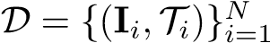 be a dataset where each image I_{i} has M captions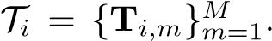We learn encoders f_{θ}(I),g_{ϕ}(T) ∈
S^{d−1} such that semantic relevance correlates with cosine similarity s(I,T) = f_{θ}(I)⊤g_{ϕ}(T).
State-space recurrence. A continuous SSM h˙(t) = Ah(t) + Bu(t), y(t) = Ch(t) + Du(t) discretized with zero-order hold and step ∆ gives

h_{t} = Ah_{t−1} + Bu_{t}, y_{t} = Ch_{t} + Du_{t}, (1)

with A = exp(∆A). SSD [4] shows that for scalar-times-identity A the recurrence admits structured block matrix computation. Our benchmark implementation uses an explicit sequential PyTorch recurrence.
Dissipative mechanics. For coordinates q, momenta p, Hamiltonian H(q,p), and damping D ≻ 0, dissipative dynamics q˙ = ∇_{p}H, p˙ = −∇_{q}H − D∇_{p}H satisfy H˙ = −∇_{p}H⊤D∇_{p}H ≤ 0. This continuous-time property motivates our construction but does not imply monotonic energy decay for the discrete learned HEDO update; “energy dissipation” refers to the damping mechanism and its physical motivation.

Proposed HEDO-HVSC Architecture
Backbone features. As shown in Fig. 1, an image I ∈ R^{3×224×224} and a caption T are encoded by frozen backbones and linearly projected:
X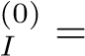 W_{proj,I} ViT-B/16(I), X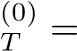 W_{proj,T} RoBERTa(T), (2)
with X⁽⁰⁾_{I} ∈ R^{B×LI×dmodel} (L_{I} = 197: 196 patches plus a class token), X⁽⁰⁾_{T} ∈ R^{B×LT×dmodel}, and a text mask M_{T} ∈ {0,1}^{B×LT} . Both backbones remain frozen in all experiments.

Hamiltonian-Inspired Energy Dissipation Operator (HEDO)
Given input coordinates q₀ ∈ R^{B×L×dmodel}, HEDO initializes momenta p₀ = tanh(W_{p}q₀) and applies a damped coordinate-momentum update with ∆t = 0.1, β = 0.05, and γ = 0.1:
p_{t+1} = p_{t}(1 − β∆t) − ∆ttanh(W_{q}q_{t}), (3) q_{t+1} = q_{t} + γ∆tp_{t+1}, HEDO(q) = LayerNorm(q_{t+1}), (4)
where W_{p},W_{q} ∈ R^{dmodel×dmodel} are learnable. With the empirical energy
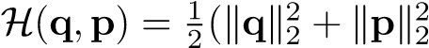), update (3) satisfies
∥p_{t+1}∥₂ ≤ (1 − β∆t)∥p_{t}∥₂ + ∆t∥tanh(W_{q}q_{t})∥₂. (5)
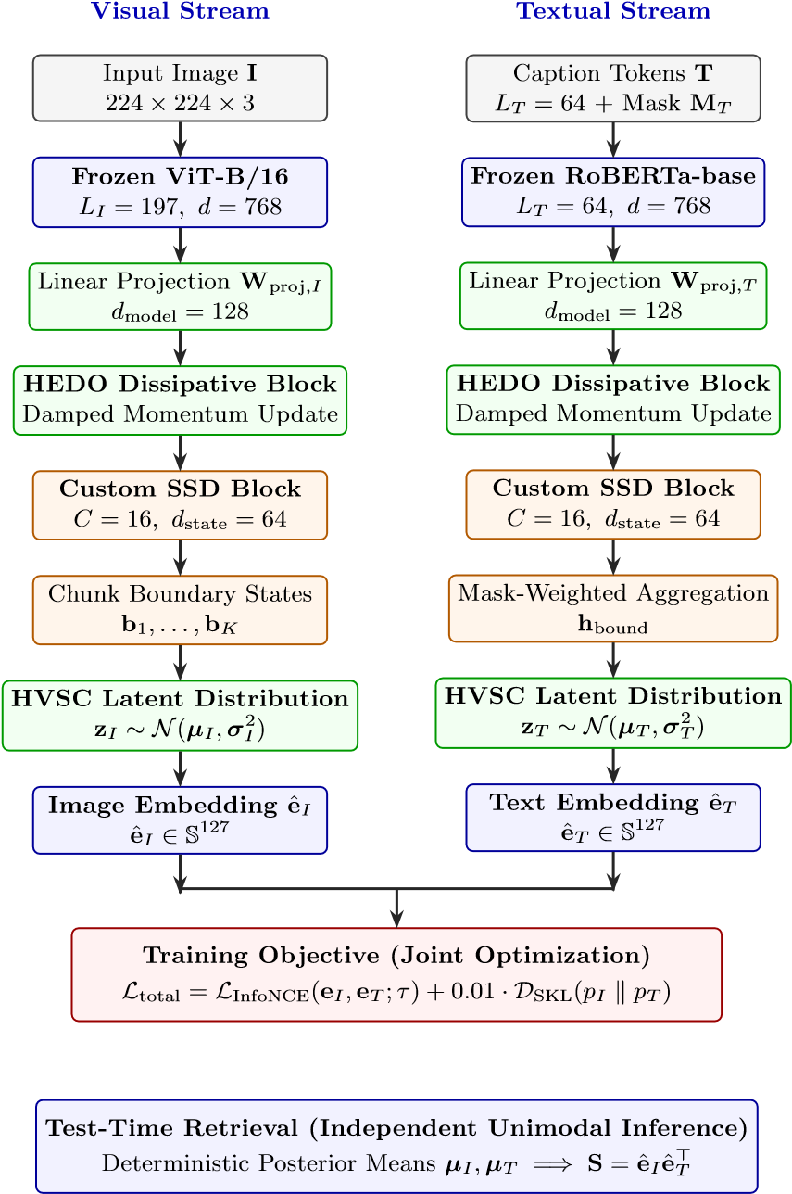
No Cross-Modal Attention | No Inter-Modality Hidden-State Exchange at Test Time
Fig.1. HEDO-HVSC pipeline. Frozen ViT-B/16 (L_{I} = 197) and RoBERTa-base (L_{T} = 64) features are projected to d_{model} = 128, transformed by HEDO, and processed by chunk-wise SSD recurrence (C = 16, d_{state} = 64). During training, boundary states parameterize Gaussian latents regularized by D_{SKL} alongside multi-positive InfoNCE; at test time, deterministic posterior means are computed strictly unimodally.
√
Since ∥tanh(·)∥₂ ≤ d_{model}, the contraction factor (1 − β∆t) = 0.995 limits momentum amplification under the bounded force term. In pre-training diagnostics, HEDO reduced image representation energy from H_{raw} = 170.824 to H_{HEDO} = 77.563 while preserving cosine similarity 0.9952; however, unforced multi-step trajectories were not monotonically decreasing (images: 170.824 → 174.387 over six steps; text: 5.849 → 5.892). We therefore describe HEDO as a damping inductive bias, not a system with guaranteed monotonic energy decay.

State-Continuous Chunk-Wise SSD-Style Recurrence
The HEDO output X is projected to d_{state} = 64 by B_{proj}, with learned decay A_{decay} = exp(−exp(A_{log})) ∈ (0,1)^{dstate}. The sequence is split into K = ⌈L/C⌉ chunks of size C = 16, and hidden states evolve as
ht = mt (Adecay ⊙ ht−1 + Bprojxt) + (1 − mt)ht−1, (6)
where m_{t} ∈ {0,1} marks valid tokens, so padded positions preserve the state. States carry across chunks (h_{start,k} = h_{end,k−1}, h_{start,1} = 0); the final state of each chunk is recorded as boundary state b_{k} with validity flag m_{k} = I(^{P}_{t∈k} m_{t} > 0) (Fig. 2).
Chunk

1
x
1
,...,x
16
h
start
,
1
=

0
b
1
=

h
end
,
1
Chunk

2
x
17
,...,x
32
h
start
,
2
=

h
end
,
1
b
2
=

h
end
,
2
Chunk
K
x
(
K
−
1)
C
+1
,...,x
L
h
start
,K
=

h
end
,K
−
1
b
K
=

h
end
,K
state

cont.
state

cont.
Mask-Weighted

Boundary

Aggregation
h
bound
=
P
K
k
=1
m
k
b
k
P
K
k
=1
m
k
+
ϵ
∈

R
B
×
d
state
Fig.2. State-continuous chunk-wise recurrence with boundary state extraction. Hidden states propagate across chunk boundaries without resets, and mask-weighted aggregation prevents padding bias.

Chunk-Wise Variational State Coupling (HVSC)
HVSC aggregates valid boundary states and parameterizes a diagonal Gaussian with z_{dim} = 64:
h_{bound} 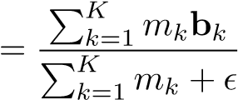, (7)
µ = Wµhbound, logσ2 = clamp(Wlogvarhbound,−5,2), (8)
with ϵ = 10⁻⁶. During training, latents are sampled as z = µ + ϵ ⊙ σ with ϵ ∼ N(0,I). The sequence is mean-pooled (mask-weighted for text) into h_{pool} and fused as e = LayerNorm(h_{pool} + αW_{out}z) with α = 0.1. Cross-modal boundary alignment is regularized in FP32 by the symmetric KL divergence
, (9)
computed analytically for diagonal Gaussians. At test time, sampling is omitted and the posterior means are used:
eˆ_{M} = Normalize LayerNorm(h_{pool,M} + αW_{out}µ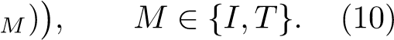
Visual and textual embeddings are thus computed independently, with no crossmodal attention or hidden-state exchange.

Training Objective
The loss is L_{total} = L_{InfoNCE} + λ_{KL}D_{SKL} with λ_{KL} = 0.01, where the multipositive InfoNCE accounts for the 5 captions per image:
LInfoNCE 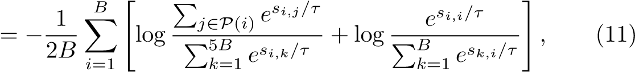
where s_{i,j} = eˆ⊤_{I,i}eˆ_{T,j}, P(i) is the positive caption set of image i, and the learnable logit scale is capped at 100. Algorithm 1 summarizes one training step.
Algorithm 1 HEDO-HVSC forward pass and training step
Require: Images I ∈ R^{B×3×224×224}, tokens T ∈ Z^{B×64}, masks M_{T}, positive index sets P
Ensure: Total loss L_{total}, test embeddings eˆ_{I},eˆ_{T}
1: Extract frozen features X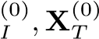 via (2)
2: Apply the HEDO transformation, if enabled, via (3)–(4)
3: Run state-continuous chunk-wise SSD recurrence; collect boundary states b_{k} and flags m_{k}
4: Aggregate boundary states and parameterize latents via (7)–(8)
5: Compute D_{SKL}(p_{I} ∥ p_{T}) in FP32 via (9)
6: Sample z and form coupled embeddings e_{I},e_{T}
7: Compute L_{InfoNCE} via (11)
8: return Ltotal ← LInfoNCE + 0.01 · DSKL

Experimental Setup
Dataset. We use Flickr8k [14]: 8,000 images with 5 captions each, split into 6,000
/ 1,000 / 1,000 images (30,000 / 5,000 / 5,000 captions) for training, checkpoint selection, and held-out testing. Disjointness of the splits was verified via image identifier hashing.
Backbones and implementation. The visual backbone is the timm checkpoint vit base patch16 224 (86.6M parameters, ImageNet normalization) and the text backbone is roberta-base (124.6M parameters, L_{T} = 64); both are frozen, and only projections, HEDO, SSD, and HVSC modules (0.330–0.422M
Table 1. Hyperparameter specification.
Hyperparameter Value Hyperparameter Value
Image resolution 224 × 224 Optimizer AdamW .999; wd 10⁻⁴)
dmodel / dstate 128 / 64 Batch size 64 images captions)
Chunk size C 16 Epochs 8
HEDO ∆t / β / γ 0.1 / 0.05 / 0.1 LR schedule Cosine, 2 × 10⁻⁴ → 10⁻⁶
HVSC latent dim 64 Gradient clipping Norm 1.0 KL weight λ_{KL} 0.01 (FP32) Seeds 42,43,44
(0
.
9
,
0

(320

Table 2. Retrieval results on the Flickr8k test split (1,000 images, 5,000 captions), mean ± standard deviation over 3 seeds. H: HEDO, V: HVSC.
Model H V
Image-to-Text

(
%
)

Text-to-Image

(
%
)
R@1

R@5

R@10

R@1

R@5

R@10

MR

(
%
)
SSD Baseline – – 26.53±0.33 57.30±0.80 70.10±1.22 20.45±0.56 49.89±0.19 65.20±0.43 48_{.25}±_{0.47} Full_{w/ow/o} _{HVSCHEDO}HEDO-HVSC ✓✓✓– ✓– 26.73±1.87 56.83±0.47 70.47±0.80 20.71±0.18 49.97±0.40 64.96±0.34 48.28±0.59

parameters) are trained. We use Python 3.12, PyTorch 2.10.0 (CUDA 12.8), timm 1.0.26, and transformers 5.0.0 on an NVIDIA Tesla T4 (16GB), with AMP FP16 and gradient scaling. Checkpoints are selected by peak validation Mean Recall (patience 3 epochs, ∆_{min} = 0.05%), and the test split is evaluated once. Table 1 lists the hyperparameters.
Protocol and metrics. Four configurations are evaluated with three seeds each (12 runs): (i) Custom SSD-Style Baseline, (ii) w/o HEDO, (iii) w/o HVSC, and (iv) Full HEDO-HVSC. Image-to-text (I2T) R@K ranks all 5,000 test captions per image and succeeds if any ground-truth caption is in the top K; textto-image (T2I) R@K ranks all 1,000 test images per caption. Mean Recall (MR) averages the six recalls. For robustness, a 100-image (500-caption) test subset was fixed a priori with seed 42 and evaluated under identical corruptions for all models; Gaussian noise was added pixel-wise with a fixed seed before clipping to [0,1].

Results
Main benchmark. Table 2 reports the aggregated test results. Full HEDO-
HVSC achieves a Mean Recall of 48.28% ± 0.59% (I2T R@1 26.73%, T2I R@1 20.71%), comparable to the baseline (48.25%±0.47%); the w/o HVSC ablation achieves the highest Mean Recall (48.43% ± 0.29%). Matched-seed deltas of the full model over the baseline are −0.14% (seed 42), −0.08% (seed 43), and +0.32% (seed 44), for a mean paired delta of +0.03% ± 0.20%. The 2 × 2 factorial interaction, ∆_{int} = MR₁₁ −MR₁₀ −MR₀₁ +MR₀₀ = 48.28−48.43−48.22+48.25 = −0.12%, is small, indicating limited interaction between HEDO and HVSC on clean data.
Robustness. To examine whether dissipation attenuates perturbations, the baseline and full model were evaluated on the fixed 100-image subset under
Table 3. Corruption stress test (Mean Re- Table ^{4.} ^{Inference} ^{latency} ^{of} ^{the} SSD call, 100-image subset). ^{block} (^{B} ⁼ 16).
Condition | Base | Full | ∆
Clean  Gaussian  Gaussian σ = 0.10 | 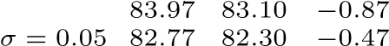  80.17 | 80.67 | +0.50
Brightness +30% | 80.43 | 79.83 | −0.60
L Latency (ms) Relative
16

2
.
894
±

0
.
021

1
.
00
×
32

5
.
436
±

0
.
034

1
.
88
×
64

10
.
315
±

0
.
052

3
.
56
×
128

19
.
713
±

0
.
089

6
.
81
×
256

38
.
602
±

0
.
141

13
.
34
×
Clean
Gauss

0.05
Gauss

0.10
Bright

+30
%
78
80
82
84
86
Subset

Mean

Recall

(
%
)
SSD

Base
line
Full

HVSC
HEDO-
Fig.3. Robustness under pixel-space perturbations on the 100-image test subset: the full model is better only under severe Gaussian noise (σ = 0.10).
pixel-space corruptions (Table 3, Fig. 3). The profile is mixed: the full model is
+0.50% better under severe Gaussian noise (σ = 0.10) but lower on clean images (−0.87%), mild noise (−0.47%), and brightness increase (−0.60%). This subset experiment is a secondary diagnostic rather than a comprehensive robustness evaluation.
Scaling and footprint. Latency was measured for L ∈ {16,...,256} (d_{model} = 128, d_{state} = 64) after 10 warm-up iterations, averaged over 50 timed iterations with explicit CUDA synchronization (Table 4). A linear fit, Latency(L) = 0.149L + 0.582ms (R² = 0.9998), characterizes the measured range; the O(L) complexity follows from the sequential recurrence itself. The full model has 0.422M trainable parameters (projections 46.7%, SSD blocks 23.3%, HVSC 22.4%, HEDO 7.8%, normalization 0.2%), under 0.21% of the
209.854M frozen backbone parameters, with 2686.25MB peak training VRAM (baseline: 0.330M, 1878.22MB; w/o HEDO: 0.356M, 1878.81MB; w/o HVSC:
0.397M, 2685.66MB).

Discussion
The full model matches the baseline on clean retrieval (paired delta +0.03% ± 0.20%). Because only three seeds were evaluated per configuration, variability is reported descriptively rather than through inferential tests. The w/o HVSC configuration attains the highest Mean Recall, so the experiments do not show that HVSC improves clean-data accuracy; its role is best interpreted as a trainingtime cross-modal boundary-distribution regularizer, with mask weighting preventing padding from contaminating boundary states. HEDO yields a small advantage under severe Gaussian noise but not across all corruptions.
What the results do not establish. The results do not establish state-ofthe-art accuracy over fine-tuned, unconstrained dual encoders; HEDO does not provide a monotonic Lyapunov stability guarantee for discrete learned dynamics; robustness is not universally superior; the PyTorch recurrence is not compared against native CUDA Mamba-2 kernels; and scaling is measured only for L ∈
[16,256].
Limitations and future work. Evaluation is limited to Flickr8k; extending it to Flickr30k [27] and MS-COCO [20] is future work. Backbones were frozen, and joint fine-tuning may increase capacity. Compiling the recurrence into native CUDA kernels should further accelerate inference.
Data and code availability. Experiments use the public Flickr8k dataset. Source code, configurations, evaluation scripts, and benchmark manifests are publicly available; the repository link is withheld for double-blind review.

Conclusion
We introduced HEDO-HVSC, a multimodal state-space framework combining a Hamiltonian-inspired discrete dissipative operator with mask-weighted chunkwise variational state coupling. In a 12-run controlled factorial benchmark on Flickr8k, HEDO-HVSC achieves retrieval performance comparable to a custom SSD-style baseline (48.28% ± 0.59% Mean Recall). Measured latency scales approximately linearly over the tested sequence lengths, consistent with the linear recurrent structure, and robustness evaluation shows a small advantage under severe Gaussian noise with mixed results under other perturbations.

References
- Alemi, A.A., Fischer, I., Dillon, J.V., Murphy, K.: Deep variational information bottleneck. International Conference on Learning Representations (ICLR) (2017)
- Cranmer, M., Greydanus, S., Hoyer, S., Battaglia, P., Spergel, D., Ho, S.: Lagrangian neural networks. ICLR Workshop on Deep Differential Equations (2020)
- Dao, T., Fu, D.Y., Ermon, S., Rudra, A., R´e, C.: FlashAttention: Fast and memoryefficient exact attention with IO-awareness. Advances in Neural Information Processing Systems (NeurIPS) 35, 16344–16359 (2022)
- Dao, T., Gu, A.: Transformers are SSMs: Generalized models and efficient algorithms through structured state space duality. Proceedings of the 41st International Conference on Machine Learning (ICML), PMLR 235, 10041–10071 (2024)
- Devlin, J., Chang, M.W., Lee, K., Toutanova, K.: BERT: Pre-training of deep bidirectional transformers for language understanding. North American Chapter of the Association for Computational Linguistics (NAACL) pp. 4171–4186 (2019)
- Dosovitskiy, A., Beyer, L., Kolesnikov, A., Weissenborn, D., Zhai, X., Unterthiner, T., Dehghani, M., Minderer, M., Heigold, G., Gelly, S., et al.: An image is worth
16x16 words: Transformers for image recognition at scale. International Conference on Learning Representations (ICLR) (2021)

- Faghri, F., Fleet, D.J., Kiros, J.R., Fidler, S.: VSE++: Improving visual-semantic embeddings with hard negatives. British Machine Vision Conference (BMVC)
(2018)
- Greydanus, S., Dzamba, M., Yosinski, J.: Hamiltonian neural networks. Advances in Neural Information Processing Systems (NeurIPS) 32 (2019)
- Gu, A., Dao, T.: Mamba: Linear-time sequence modeling with selective state spaces. arXiv preprint arXiv:2312.00752 (2023)
- Gu, A., Dao, T., Dao, S., Ermon, S., R´e, C.: HiPPO: Recurrent memory with optimal polynomial projections. Advances in Neural Information Processing Systems (NeurIPS) 33, 1474–1487 (2020)
- Gu, A., Goel, K., R´e, C.: Efficiently modeling long sequences with structured state spaces. International Conference on Learning Representations (ICLR) (2022)
- He, K., Zhang, X., Ren, S., Sun, J.: Deep residual learning for image recognition. IEEE/CVF Conference on Computer Vision and Pattern Recognition (CVPR) pp.
770–778 (2016)
- Hendrycks, D., Dietterich, T.: Benchmarking neural network robustness to common corruptions and perturbations. International Conference on Learning Representations (ICLR) (2019)
- Hodosh, M., Young, P., Hockenmaier, J.: Framing image description as a ranking task: Data, models and evaluation metrics. Journal of Artificial Intelligence
Research 47, 853–899 (2013). https://doi.org/10.1613/jair.3994
- Jia, C., Yang, Y., Xia, Y., Chen, Y.T., Parekh, Z., Pham, H., Le, Q., Ku, S.Y., Wang, J., Duerig, T.: Scaling up visual and vision-language representation learning with noisy text supervision. Proceedings of the 38th International Conference on Machine Learning (ICML) pp. 4904–4916 (2021)
- Kingma, D.P., Welling, M.: Auto-encoding variational Bayes. International Conference on Learning Representations (ICLR) (2014)
- Lee, K.H., Chen, X., Hua, G., Houdusse, H., Vassilvitskii, S.: Stacked cross attention for image-text matching. Proceedings of the European Conference on Computer Vision (ECCV) pp. 201–216 (2018)
- Li, J., Li, D., Savarese, S., Hoi, S.: BLIP-2: Bootstrapping language-image pretraining with frozen image encoders and large language models. Proceedings of the 40th International Conference on Machine Learning (ICML) pp. 19730–19742
(2023)
- Li, J., Li, D., Xiong, C., Hoi, S.: BLIP: Bootstrapping language-image pre-training for unified vision-language understanding and generation. Proceedings of the 39th International Conference on Machine Learning (ICML) pp. 12888–12900 (2022)
- Lin, T.Y., Maire, M., Belongie, S., Hays, J., Perona, P., Ramanan, D., Dolla´r, P.,
Zitnick, C.L.: Microsoft COCO: Common objects in context. Proceedings of the
European Conference on Computer Vision (ECCV) pp. 740–755 (2014)
- Liu, Y., Ott, M., Goyal, N., Du, J., Joshi, M., Chen, D., Levy, O., Lewis, M., Zettlemoyer, L., Stoyanov, V.: RoBERTa: A robustly optimized BERT pretraining approach. arXiv preprint arXiv:1907.11692 (2019)
- Massaroli, S., Poli, M., Califano, F., Faragasso, A., Park, J., Yamashita, A., Asama,
H.: Port-hamiltonian approach to neural network training. In: Proceedings of the
2019 IEEE 58th Conference on Decision and Control (CDC). pp. 6799–6806 (2019).
https://doi.org/10.1109/CDC40024.2019.9030017
- Radford, A., Kim, J.W., Hallacy, C., Ramesh, A., Goh, G., Agarwal, S., Sastry, G., Askell, A., Mishkin, P., Clark, J., et al.: Learning transferable visual models from natural language supervision. Proceedings of the 38th International Conference on Machine Learning (ICML) pp. 8748–8763 (2021)
- Smith, J.T.H., Warrington, A., Linderman, S.W.: Simplified state space layers for sequence modeling. International Conference on Learning Representations (ICLR)
(2023)
- Vaswani, A., Shazeer, N., Parmar, N., Uszkoreit, J., Jones, L., Gomez, A.N., Kaiser, L ., Polosukhin, I.: Attention is all you need. Advances in Neural Information Processing Systems (NeurIPS) 30 (2017)
- Wang, W., Bao, H., Dong, L., Bjorck, J., Peng, Z., Liu, Q., Aggarwal, K., Mohammed, O.K., Singhal, S., Som, S., et al.: Image as a foreign language: BEiT-3 pretraining for vision-language tasks. IEEE/CVF Conference on Computer Vision and Pattern Recognition (CVPR) pp. 19175–19186 (2023)
- Young, P., Lai, A., Hodosh, M., Hockenmaier, J.: From image descriptions to visual denotations: New similarity metrics for semantic inference over event descriptions. Transactions of the Association for Computational Linguistics (TACL) 2, 67–78 (2014). https://doi.org/10.1162/TACL_A_00166

